Applied Communication – Auto Time
Editing your video

So you’re finished recording your video clips. Now it’s time to put them together, add features, and fix up any mistakes. We’ll be using Windows Movie Maker to edit the videos. Here is a list of what you can do with the software.

- Add a title screen
- Add transitions between video clips to avoid jumpy scene switches (there are a variety of options – subtlety is more effective here)
- Add text on your video – lots of groups have done this in the past for the tools/supplies section or cautions/warnings
- Add title screen or background music
- Add video effects (black and white, old film look, etc. – there probably isn’t a good use for these in your video)
- Arrange the order of the video clips (useful if you recorded your segments out of chronological order)
- Add still images (useful if part of what you’re trying to show didn’t turn out well – for example, if you’re trying to show the location of the oil drain plug and the video camera didn’t pick it up well, you can add a photo of the oil drain plug so the viewer knows what to look for. It might also be useful if you forgot to include a needed part/tool, etc).
- Add an ending screen and/or moving credits
- Trimming out bloopers, signals meant for the camera person, etc.
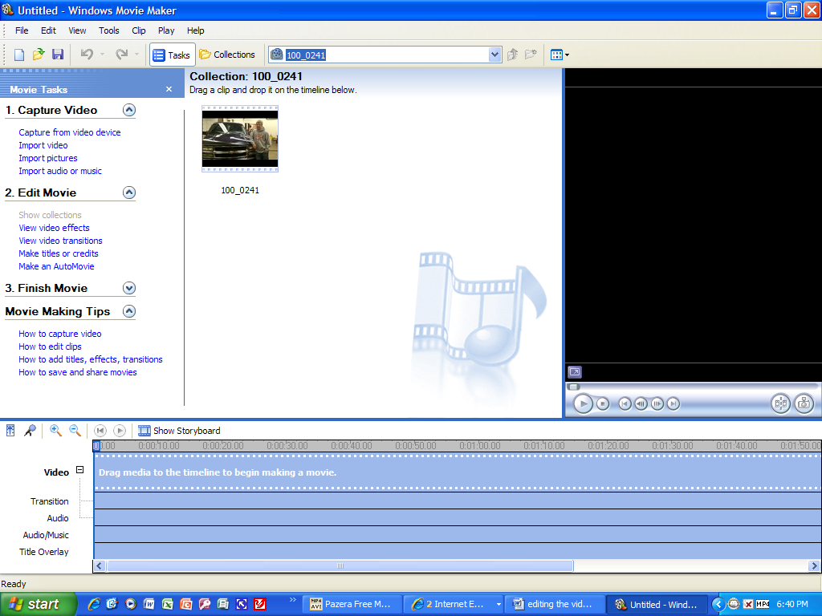
Here is the Windows Movie Maker user interface. After importing your video, drag each video clip you will use to the timeline (or storyboard) and rearrange them as necessary by dragging and dropping. Then, use the links under 2.Edit Movie to apply text of any kind or add transitions. Save your Movie Maker Project file in your p-drive. When you have finished editing, you’ll use your Movie Maker Project file to create an actual standalone video file as the final step.

