Hi-Lights I - In-depth reporting
Centerspread design/layout – final exam – 200 points

Stories:
For this project, you will work with a partner. After picking a topic for a centerspread, you and your partner will pick three story ideas based on this topic to turn into stories for a centerspread which you will design and layout together.

Example topic: The Green Revolution
Story 1 – What PHS students/faculty do (or don’t do) to be green
Story 2 – More hybrid cars being produced, new 100% electric cars to be available for consumers later this year
Story 3 – Government initiatives supporting the green revolution and their impacts on the economy, students

Your centerspread must include:
- All of the stories you and your partner wrote
- A headline for each story
- A title - “Going Green,” “Communication Changes in the Digital Age,” etc. – use a large font and avoid putting the title directly in the center of the spread unless there is a compelling reason to do so.
- At least two photos or graphics that add visual interest/understanding to your theme. There should be an obviously dominant photo/graphic
- Use of color – remember to edit images/graphics by saving them in CMYK color mode!
- At least one lightly shaded box (no more than 20% color) behind a story.
- A “voices in the hall” style piece (extracted photos work well for this!) and/or “consider this” style quotes/statistics pertaining to your theme. Be sure to mention the source of ALL statistics you use. (4 is a good number for voices in the hall, and at least 5 is good for consider this.)
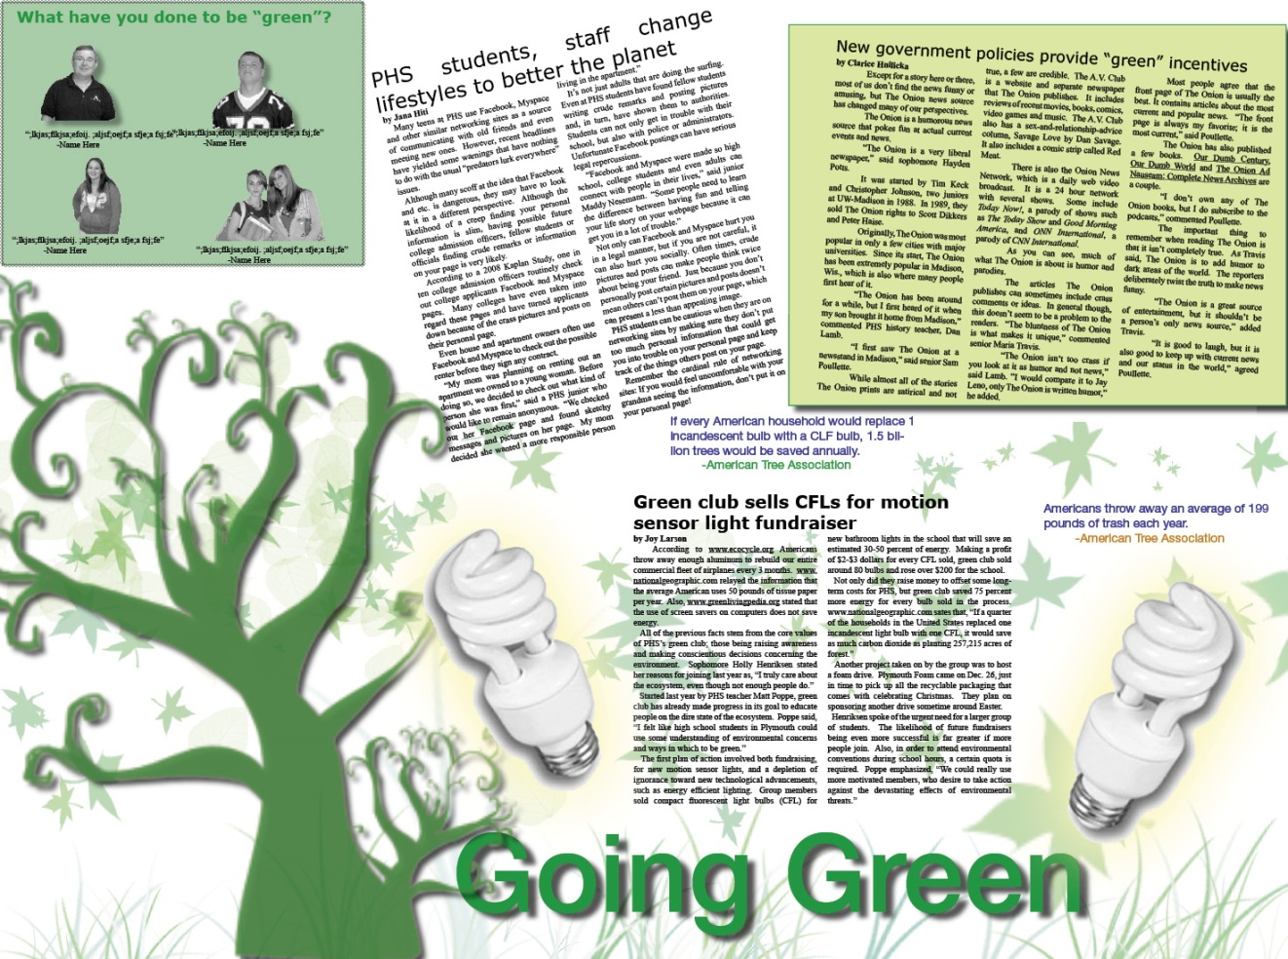
Color box behind story – helps create clarity, visual interest
Voices in the hall quotes, photos; piece offset by color box background
Consider this quotes/statistics – can be placed at random or put together as a sidebar
CFL bulbs – extracted photo, drop shadow and outer glow added in Photoshop
Dominant graphic (from Photoshop brush)
Spread title – large, in color, not in center of the spread

Grass, leaves (from Photoshop brush)– for visual interest, color. Made partly transparent to allow easy reading of text
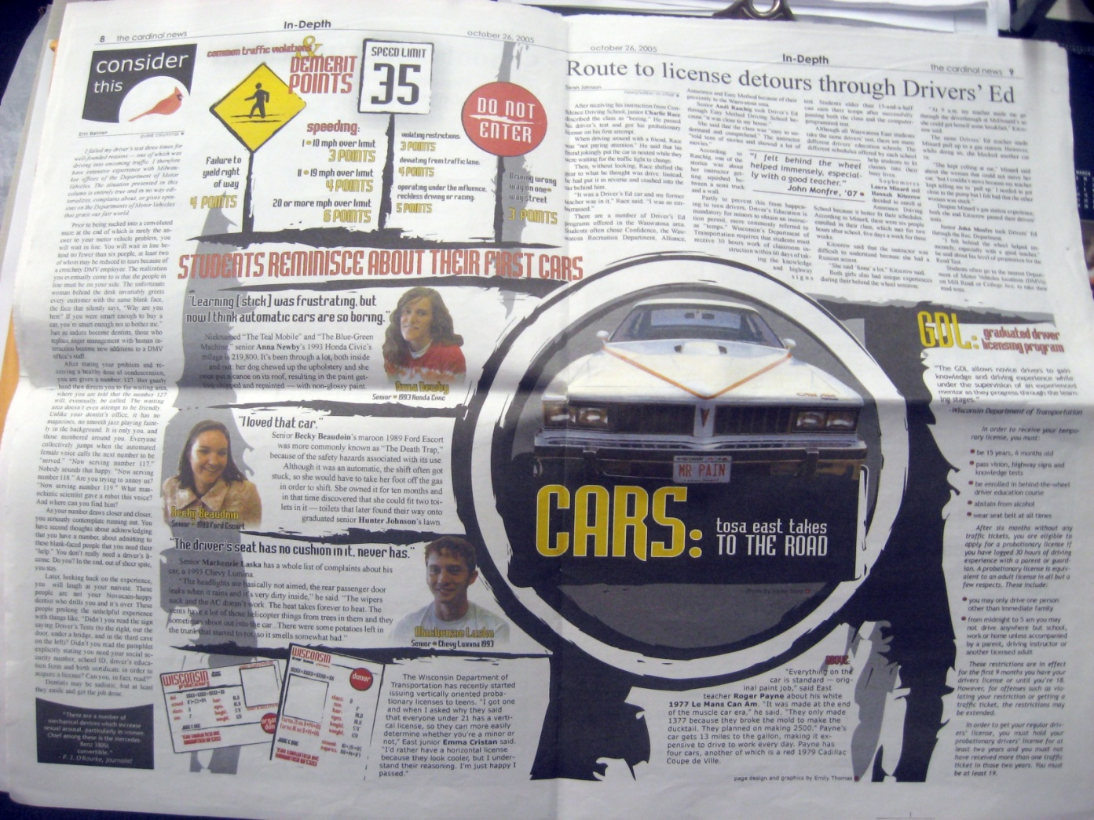

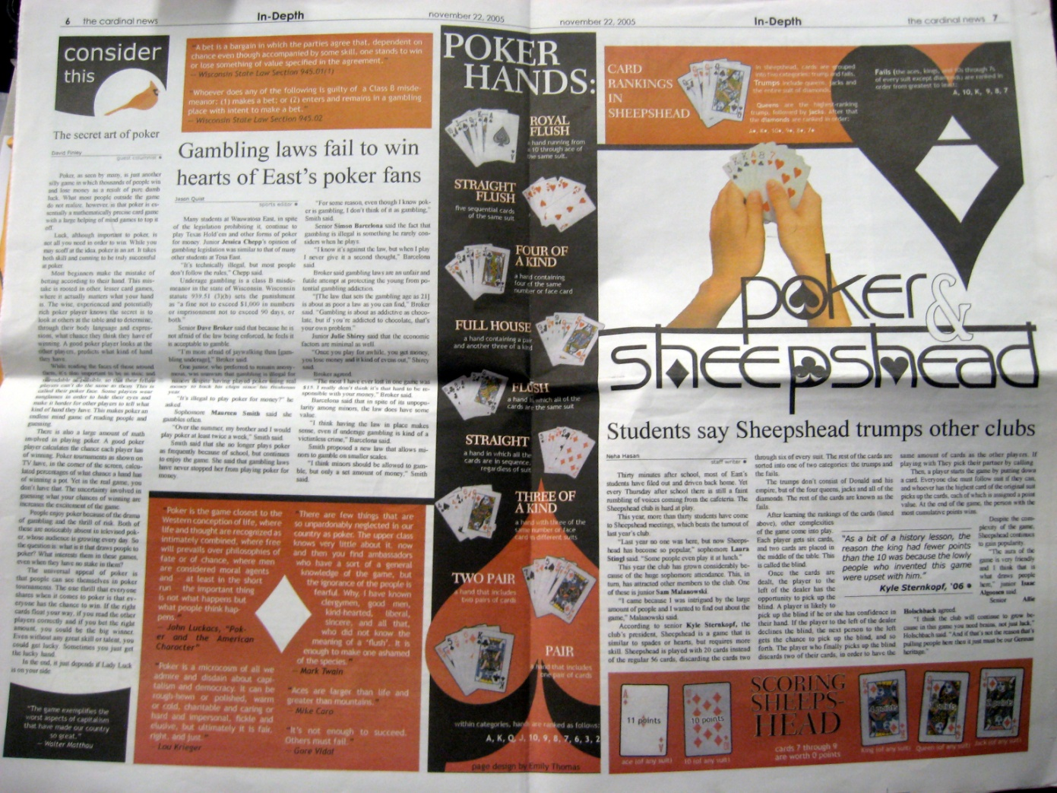

News/Feature/General Entertainment Story Assessment
 | A | B | C | D
Content  50 | - Successfully concise, attention-  grabbing lead  - Very well detailed with all information relevant  - Completely avoids editorializing  -Very effective use of quotes and paraphrasing | - Lead attempts to go beyond the 5ws and h  - Well detailed with nearly all information relevant  - May have one or two minor instances of editorializing  -Effective use of quotes and paraphrasing | - Basic lead sticks to 5 ws and h  - Good detail with most information relevant  - Generally avoids editorializing  -Very effective use of quotes and paraphrasing | - Lead lacks basic information  - Lacking in detail or information relevancy  - Openly editorializes  -Minimal or ineffective use of quotes and paraphrasing
Organization  25 | - Information presented in logical fashion  - The sentences flow logically - one very clearly clearly leads into the next  - Short, concise, unified paragraphs flow logically | - Information presented in mostly logical fashion  - The sentences mostly flow logically - one clearly leads into the next  - Short, concise, unified paragraphs mostly flow logically | - Information presented in somewhat logical fashion  - The sentences sometimes flow logically - one generally leads into the next  - Paragraphs may be lengthy but may possess some degree of unity and logical flow | - Information not often presented in logical fashion  - The sentences do not often flow logically  - Paragraphs too lengthy and possess little, if any, unity and logical flow
Conventions  25 | -Thoroughly demonstrates mastery of AP/Hi-Lights writing and formatting styles  - Nearly flawless grammar/ spelling/ punctuation | - Demonstrates strong hold on AP/Hi-Lights writing and formatting styles  - Contains grammar/spelling/punctuation errors that begin to detract from the content | - Demonstrates developing hold on AP/Hi-Lights writing and formatting styles  - Contains grammar/spelling/ punctuation errors that clearly detract from the content | - Demonstrats beginning hold on AP/Hi-Lights writing and formatting styles  - Contains many grammar/spelling/punctuation errors; they overshadow the content

Layout Assessment
 | A | B | C | D
Design  60 | - Clear dominant photo/graphic present  - Photo/graphic placement is balanced very well throughout spread  - Very clear layout obvious at first glance | - Dominant photo/graphic present  - Photo/graphic placement is balanced well throughout spread  - Clear layout obvious at first glance | - Photos/graphics may be very similar in size  - Photo/graphic placement is mostly balanced throughout spread  - Layout easy to follow at quick glance | - Photo/graphic sizes are indistinguishable  - Photos/graphics are placed haphazardly or stacked with little consideration of balance  - Layout may confuse at a quick glance
Style  40 | -Page layout is almost flawless in following Hi-Lights layout style | - Page contains several errors in Hi-Lights layout style that begin to detract from the layout | - Page contains numerous errors in Hi-Lights layout style that clearly detract from the effectiveness of the layout | - Page contains many errors in Hi-Lights layout style; they overshadow the effectiveness of the layout

